**Wei Liang** **SP17**

**CST 2309-E286**

**Lab#3**

**Prof. Sancar Avcioglu February 8, 2017**

**Lab#3**

1. Using an HTML <a> and </a> anchor tag pair, create a text-based hyperlink to this book’s

**[Firefox]**

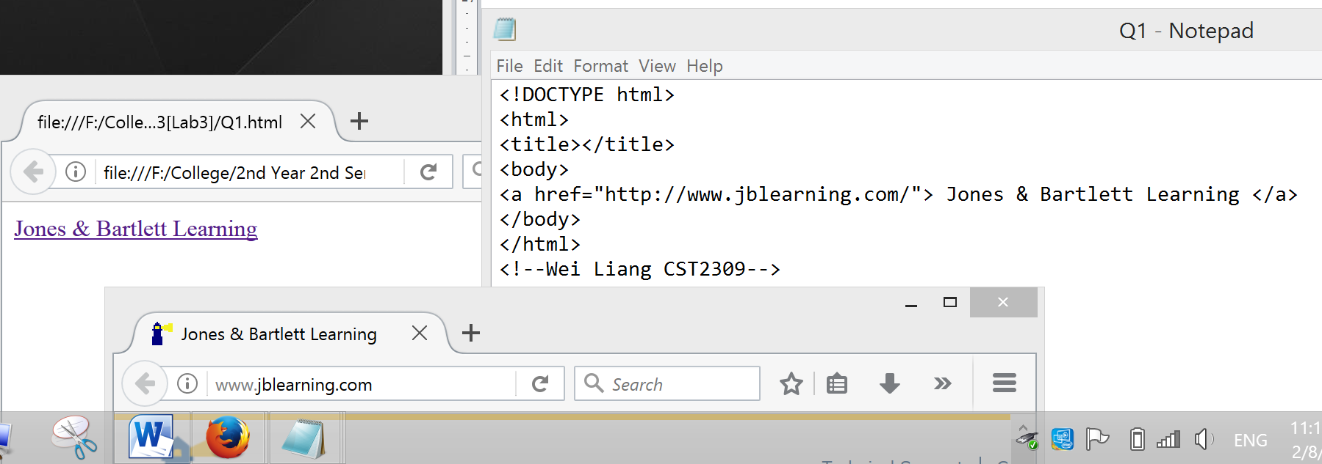

2. Using an HTML <a> and </a> anchor tag pair, and the image file at

**[Chrome]**

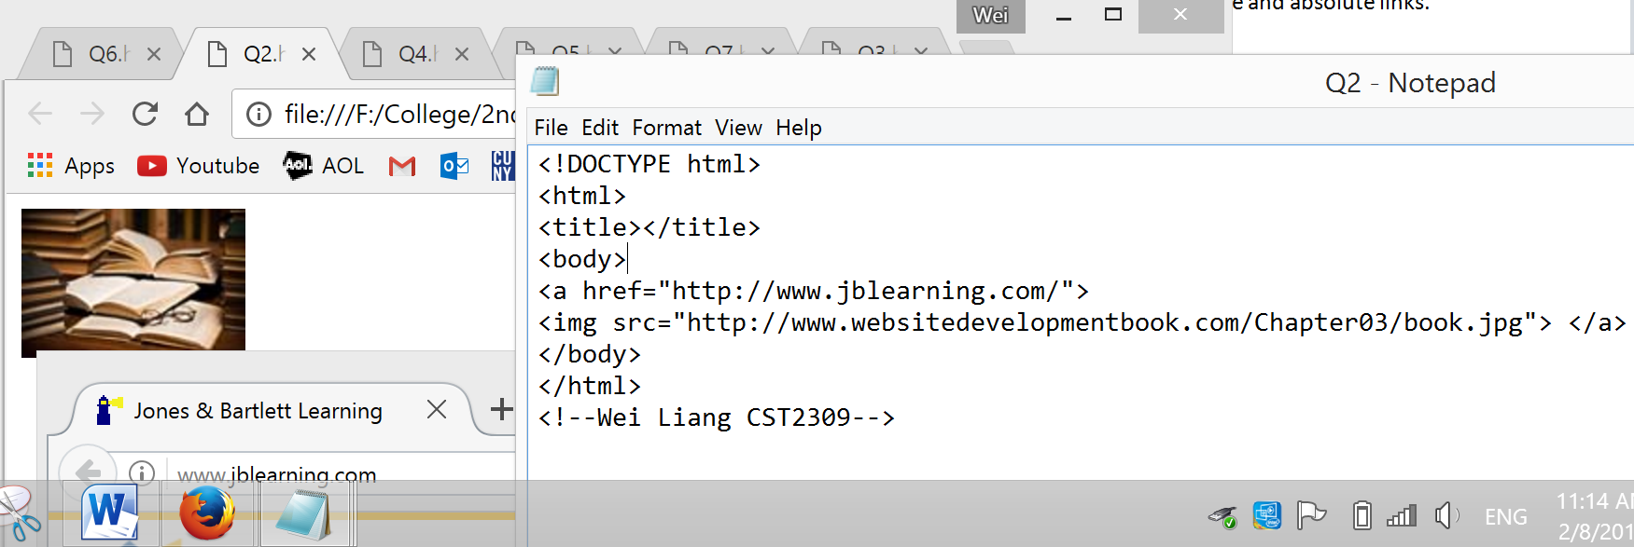

3. Create an HTML file that illustrates the difference between relative and absolute links.

**[Chrome]**

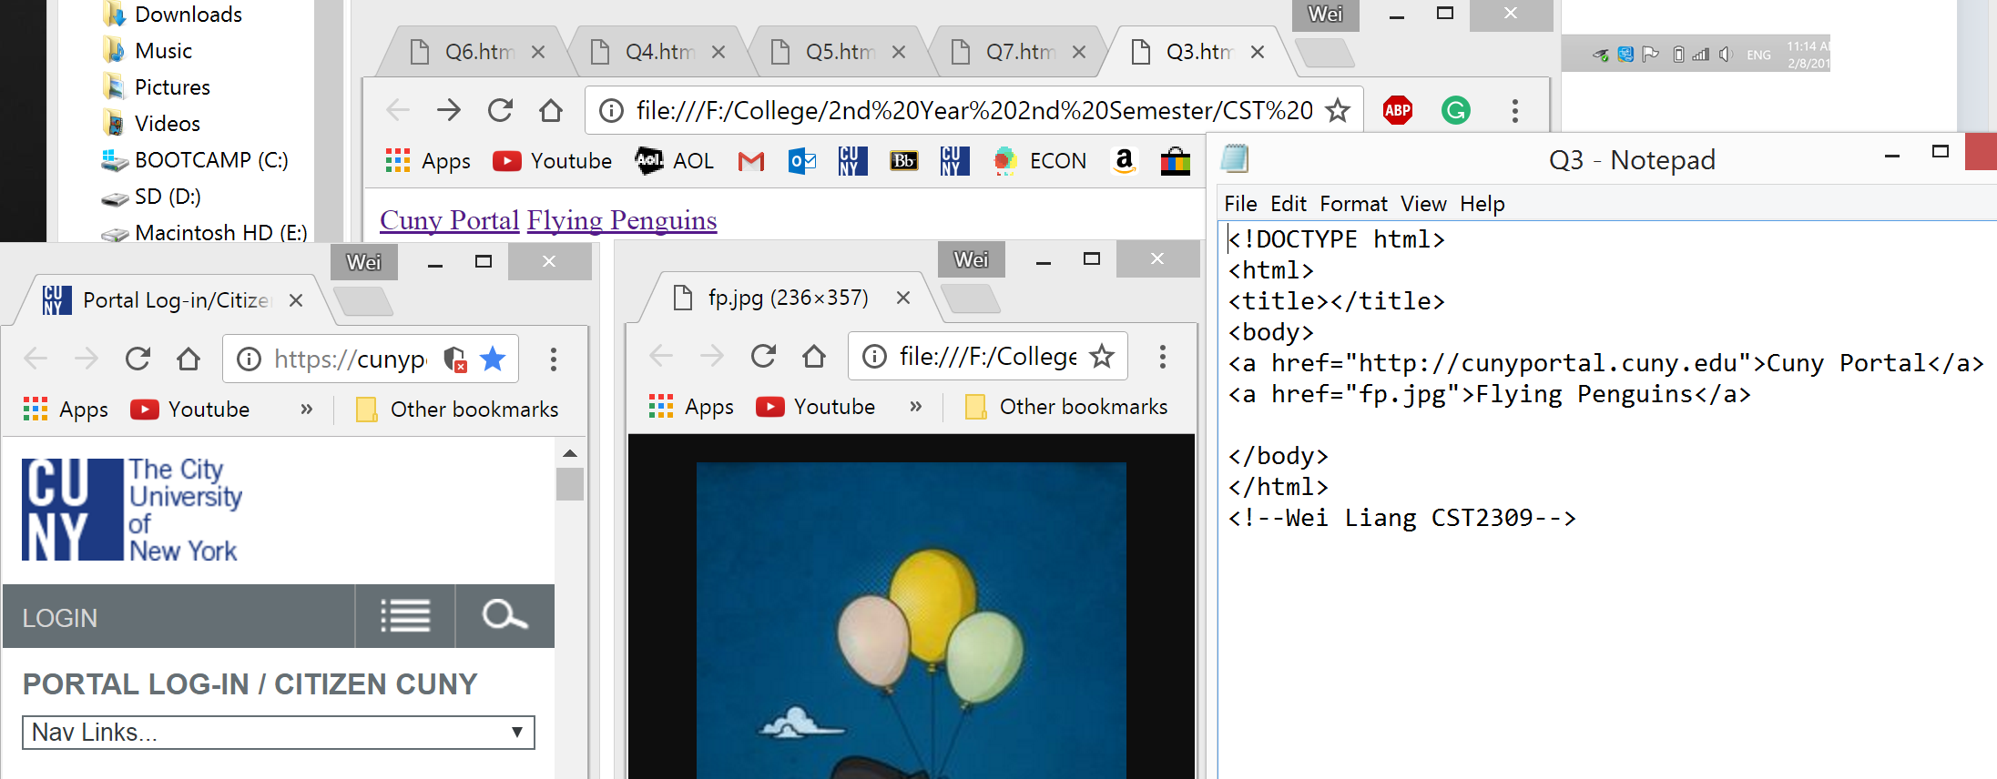

4. Create an HTML file that illustrates the use of the mailto attribute. **[FireFox]**

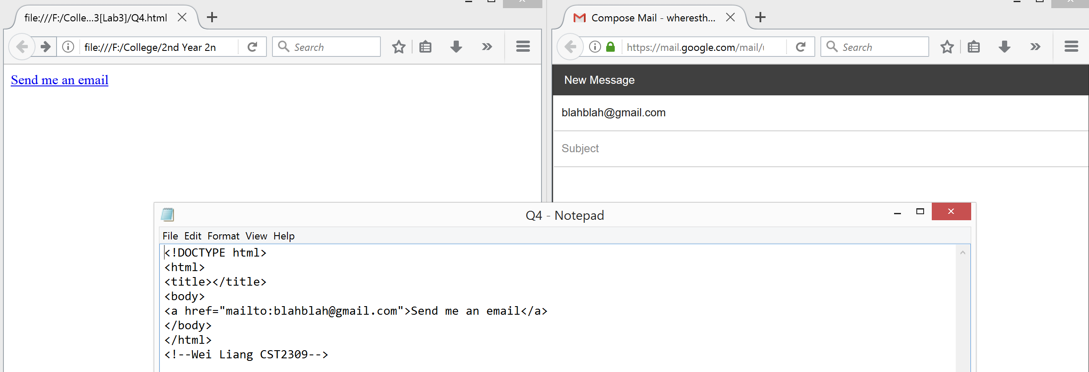

5. Modify the HTML file you created in Question 1 to open the link in a new window.

**[Chrome]**

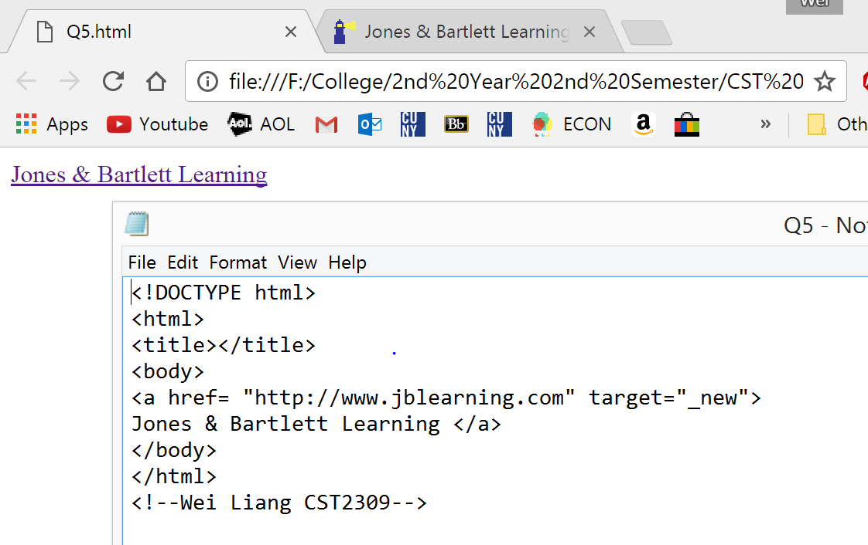

6. Create an HTML file that illustrates the use of an in-page link.

**[Chrome]**

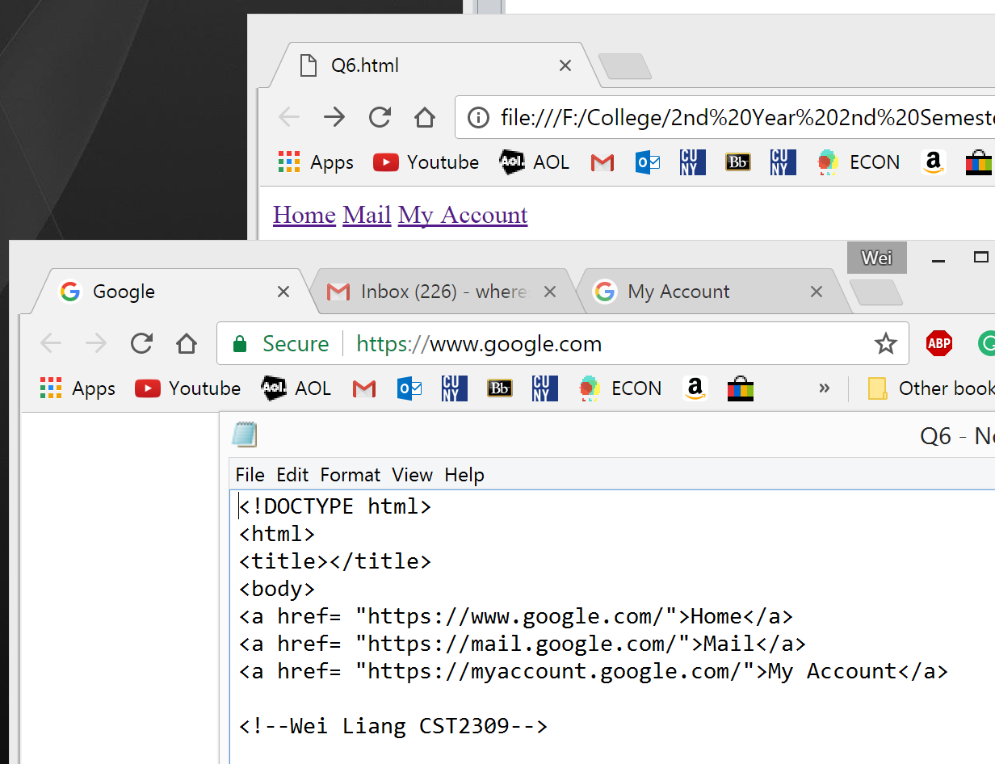

7. Create an HTML file that uses an image map.

**[Chrome]**

